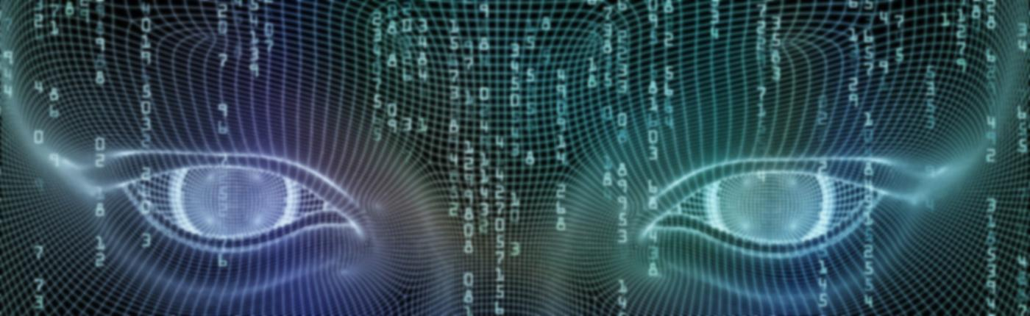

*ARTIFICIAL*

*INTELLIGENCE*



A

rtificial Intelligence (AI) is truly a revolutionary feat of computer science, set to become a core component of all modern software over the coming years and decades. This presents a threat but also an opportunity. AI will be deployed to augment both defensive and offensive cyber operations. Additionally, new means of cyber attack will be invented to take advantage of the particular weaknesses of AI technology. Finally, the importance of data will be amplified by AI’s appetite for large amounts of training data, redefining how we must think about data protection. Prudent governance at the global level will be essential to ensure that this era-defining technology will bring about broadly shared safety and prosperity.

STARS Articles

STARS articles are peer-reviewed articles on the history of major developments in technology. Available in the computers and information processing category are:

* Differential Analyzers
* Early Punched Card Equipment, 1880 - 1951
* Early Popular Computers, 1950 - 1970
* Electronic Calculators: Desktop to Pocket
* IBM System/360
* Inventing the Computer
* Software Industry
* Word Processing for the Japanese Language

AI and Big Data

In general terms, AI refers to computational tools that are able to substitute for human intelligence in the performance of certain tasks. This technology is currently advancing at a breakneck pace, much like the exponential growth experienced by database technology in the late twentieth century. Databases have grown to become the core infrastructure that drives enterprise-

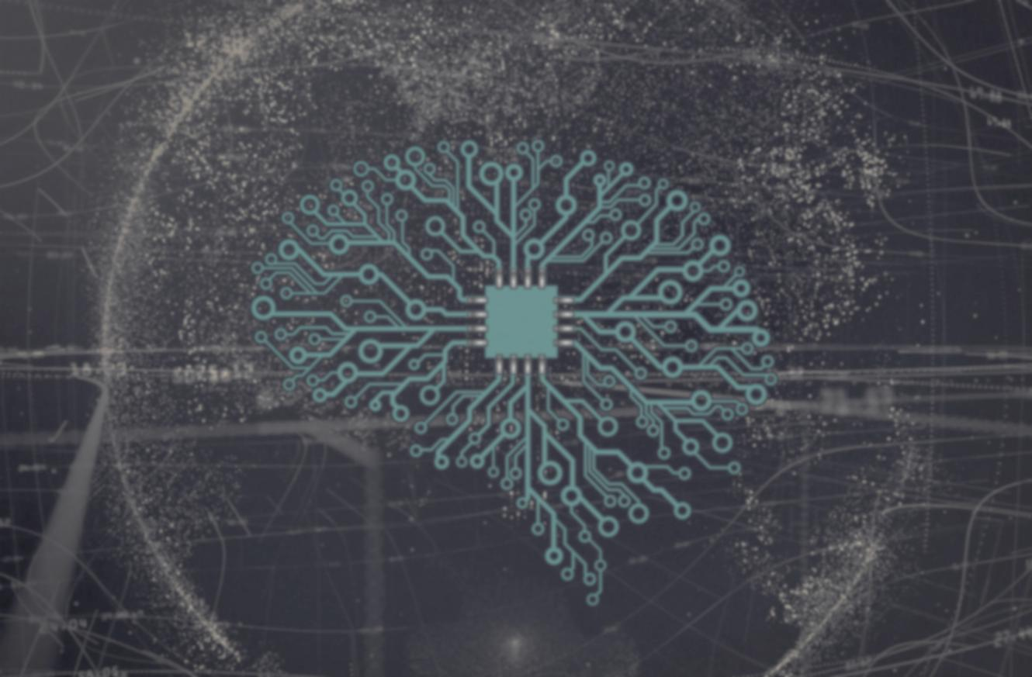level software. Similarly, most of the new value added from software over the coming decades is expected to be driven, at least in part, by AI.

Within the last decade, databases have evolved significantly in order to handle the new phenomenon dubbed “big data.” This refers to the unprecedented size and global scale of modern data sets, largely gathered from the computer systems that have come to mediate nearly every aspect of daily life. For instance, YouTube receives over 400 hours of video content each minute (Brower 2015).

**NOTE:** For instance, researchers have trained computer models to identify an individual’s personality traits more accurately than their friends based exclusively on what Facebook posts they had liked.

Big data and AI have a special relationship. Recent breakthroughs in AI development stem mostly from “machine learning.” Instead of dictating a static set of directions for an AI to follow, this technique trains AI by using large data sets. For example, AI catboats can be trained on data sets containing text recordings of human conversation collected from messenger apps to learn how to understand what humans say, and to come up with appropriate responses (Pander 2018). One could say that big data is the raw material that fuels AI algorithms and models.

The main constraint on innovation is no longer the difficulty in recording and storing information, but the finding of useful insights among the sheer abundance of data now being collected. AI can notice patterns in mammoth data sets that are beyond the ability of human perception to detect. In this way, the adoption of AI technology can make even mundane and seemingly trivial data valuable. For instance, researchers have trained computer models to identify an individual’s personality traits more accurately than their friends can, based exclusively on what Facebook posts the individual had liked (Wu, Kolinsky and Stillwell 2015).

Humans VS Computers

|  |  |  |  |
| --- | --- | --- | --- |
| Systems that think like Humans | Systems that act like Humans | Systems that think like Humans | ` Systems that act like Humans |
| “The exciting new effort to make computers think …machines with minds ,in the full and literal sense” | “The art of creating machines that perform functions that require Intelligence performed by people” | “The study of mental faculties through the use of computational models” | “A field of study that seeks to explain and emulate intelligent behavior in term of computational processes” |
| “The automatic of activities that we associate with humans thinking , activities” | “The study of how to make computers do things at which , at the moment , people  Are better” | “The study of computation that make it possible to perceive reason and act” | “The branch of computer science that is concerned with the automation of intelligent behavior” |